QingCloud QKCP install guide

- docker:
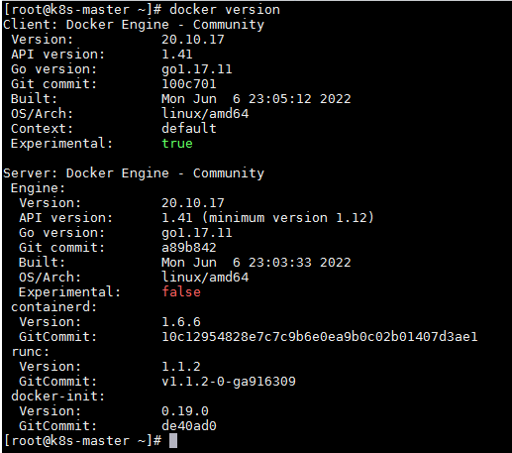
- QKCP
curl -OL https://139.198.5.33/kubesphere/qkcp/qkcp-all-v3.2.1-offline-linux-amd64.tar.gz -u kubesphere:Qcloud@123 -k

chmod +x qkcp-all-v3.2.1-offline-linux-amd64.tar.gz
tar -zxvf qkcp-all-v3.2.1-offline-linux-amd64.tar.gz
chmod +x kubekey-artifact.tar.gz
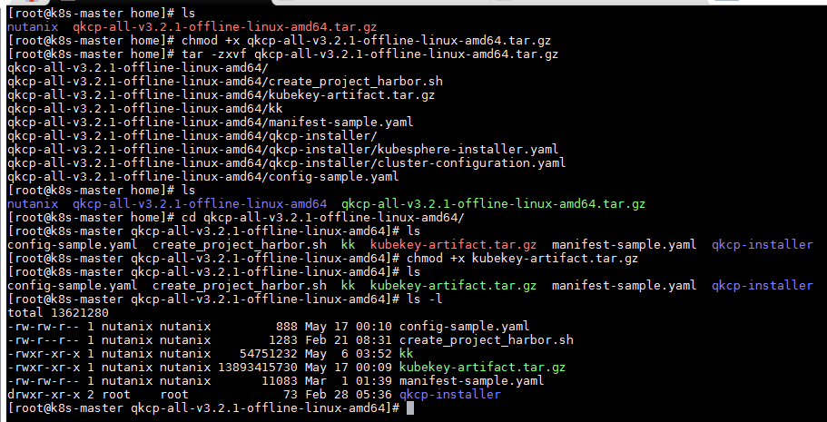

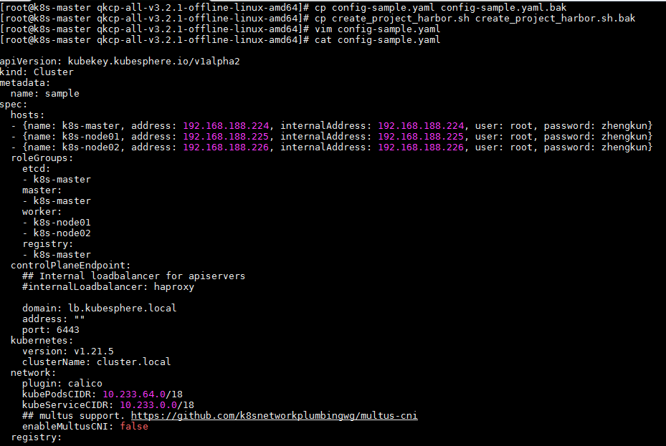

sudo ./kk init registry -f config-sample.yaml -a kubekey-artifact.tar.gz
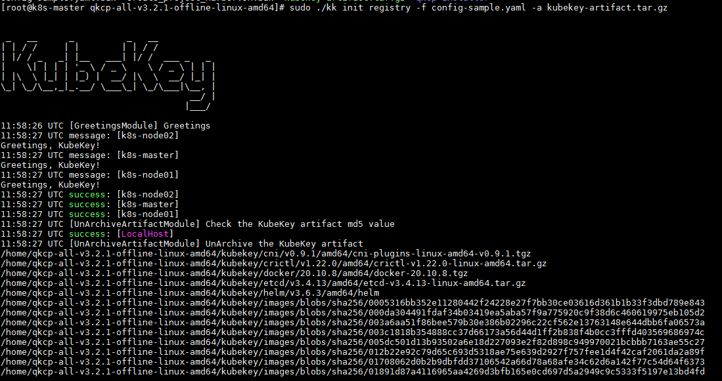

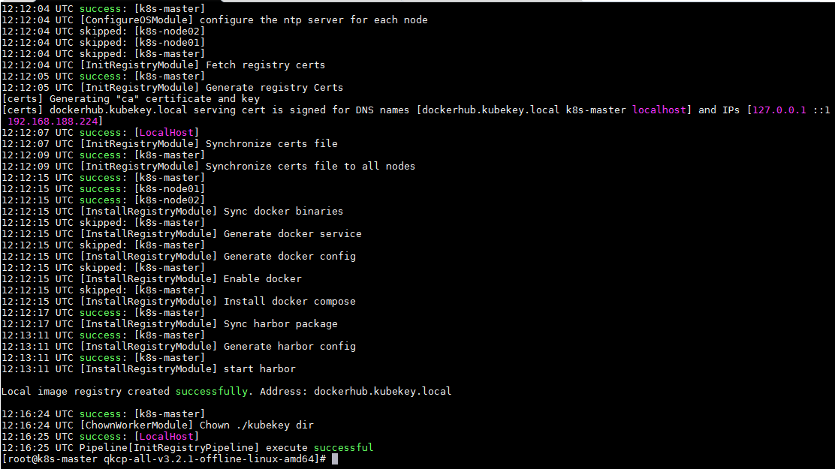

chmod +x ./create_project_harbor.sh
sudo ./create_project_harbor.sh
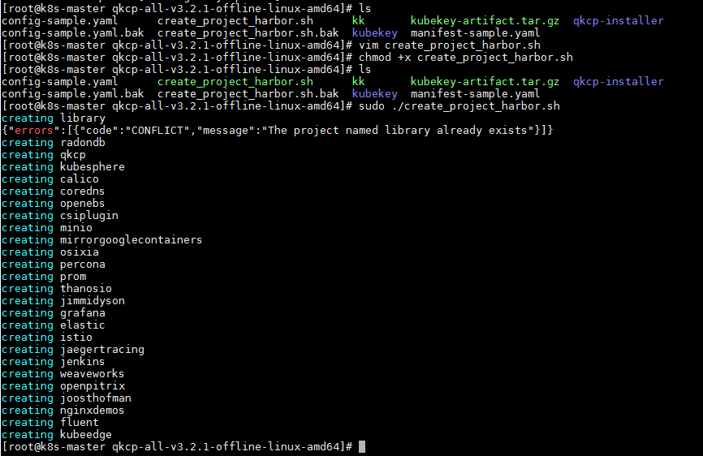

sudo ./kk create cluster -f config-sample.yaml -a kubekey-artifact.tar.gz --with-local-storage --with-packages
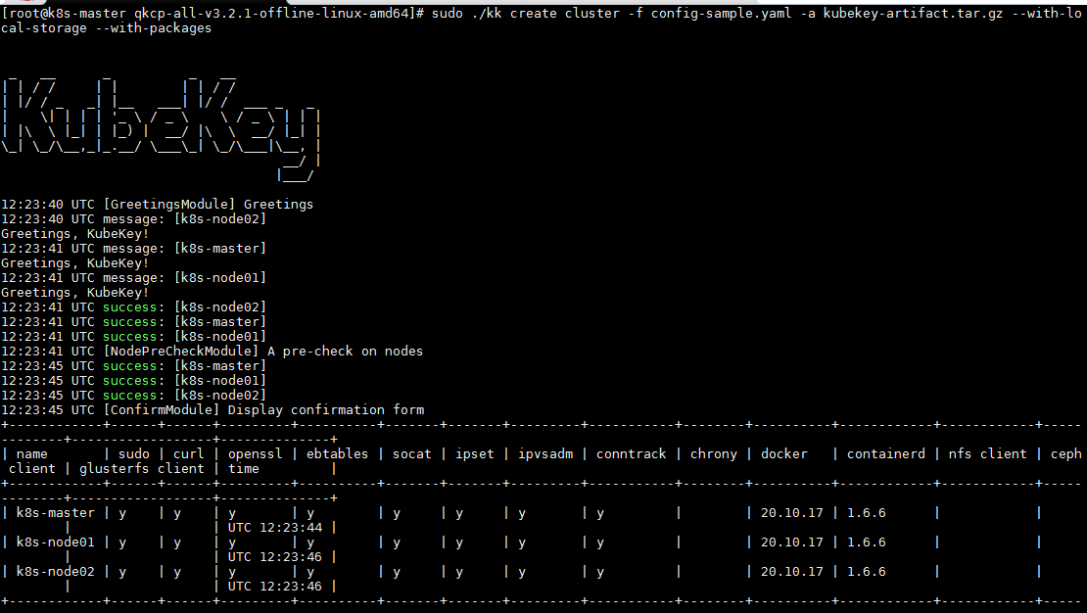

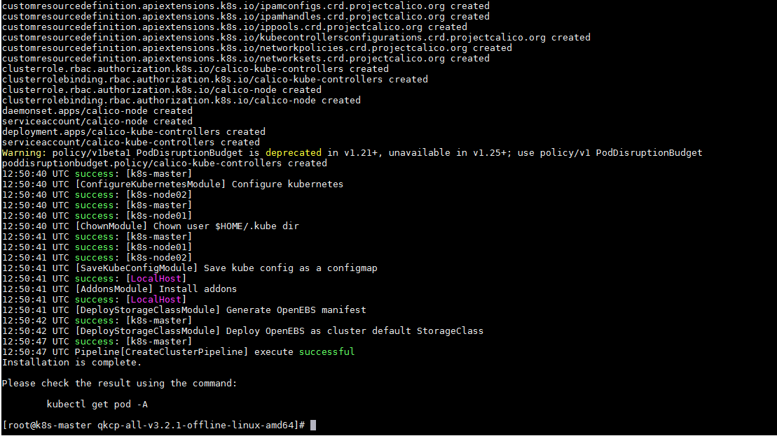

kubectl get pod –A
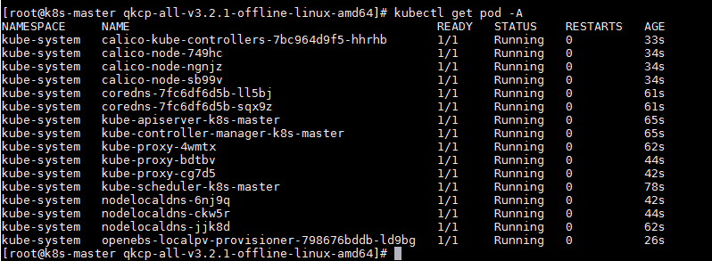

kubectl create ns kubesphere-monitoring-system
kubectl -n kubesphere-monitoring-system create secret generic kubeetcd-client-certs --from-file=etcd-clientca.crt=/etc/ssl/etcd/ssl/ca.pem --from-file=etcdclient.crt=/etc/ssl/etcd/ssl/node-k8s-master.pem --from-file=etcdclient.key=/etc/ssl/etcd/ssl/node-k8s-master-key.pem
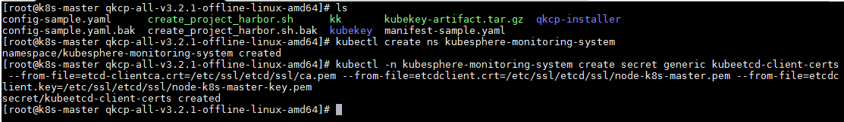

vim cluster-configuration.yaml
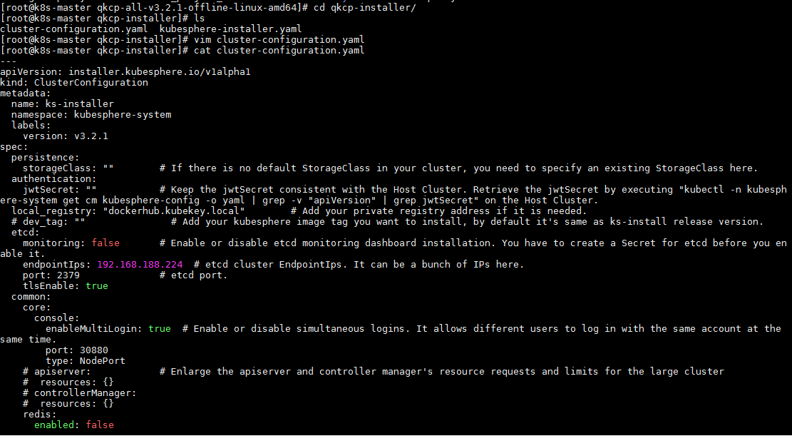

kubectl apply -f kubesphere-installer.yaml
kubectl apply -f cluster-configuration.yaml
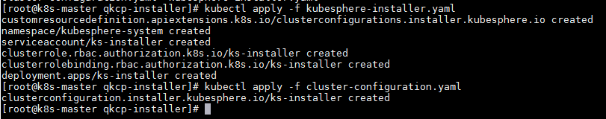

kubectl logs -n kubesphere-system $(kubectl get pod -n kubesphere-system -l app=ks-installer -o jsonpath='{.items[0].metadata.name}') –f
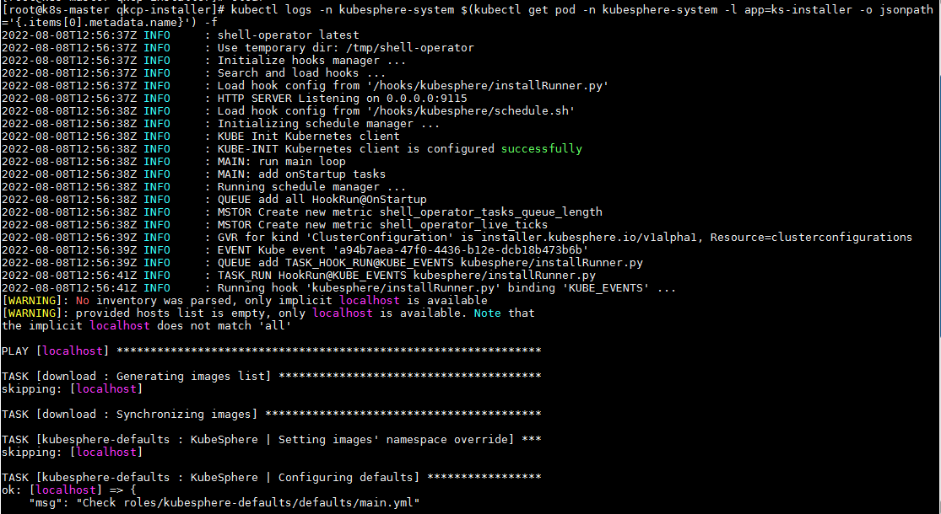

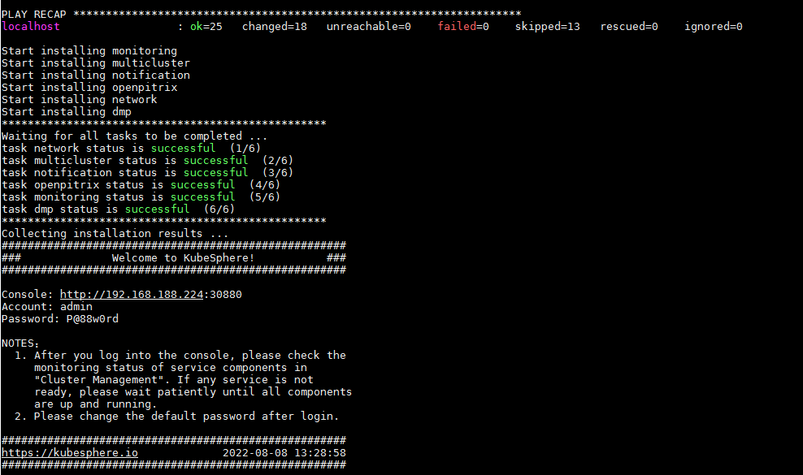

Console: http://192.168.188.224:30880
Account: admin
Password: P@88w0rd

